Lab 6: Perform RPC, SMB, and FTP Enumeration

**Lab Scenario**

As an ethical hacker or penetration tester, you should use different enumeration techniques to obtain as much information as possible about the systems in the target network. This lab will demonstrate various techniques for extracting detailed information that can be used to exploit underlying vulnerabilities in target systems, and to launch further attacks.

**Lab Objectives**

* Perform SMB enumeration using NetScanTools Pro
* Perform RPC, SMB, and FTP enumeration using Nmap

**Overview of Other Enumeration Techniques**

Besides the methods of enumeration covered so far (NetBIOS, SNMP, LDAP, NFS, and DNS), various other techniques such as RPC, SMB, and FTP enumeration can be used to extract detailed network information about the target.

* **RPC Enumeration**: Enumerating RPC endpoints enables vulnerable services on these service ports to be identified
* **SMB Enumeration**: Enumerating SMB services enables banner grabbing, which obtains information such as OS details and versions of services running
* **FTP Enumeration**: Enumerating FTP services yields information about port 21 and any running FTP services; this information can be used to launch various attacks such as FTP bounce, FTP brute force, and packet sniffing

Task 1: Perform SMB Enumeration using NetScanTools Pro

NetScanTools Pro is an integrated collection of Internet information-gathering and network-troubleshooting utilities for network professionals. The utility makes it easy to find IPv4/IPv6 addresses, hostnames, domain names, email addresses, and URLs related to the target system.

Here, we will use the NetScanTools Pro tool to perform SMB enumeration.

1. Click [Windows 10](https://labclient.labondemand.com/Instructions/fbc14e54-d7e0-48c8-a161-917c8a669df5?rc=10) to switch to the **Windows 10** machine.
2. Double-click the **NetScanTools Pro Demo** icon from **Desktop** to launch the tool.

If the **Reminder** window opens, click **Start the DEMO**, and in the **DEMO Version** window, click **Start NetScanTools Pro Demo…**.

1. The **NetScanTools Pro** main window appears, as shown in the screenshot.

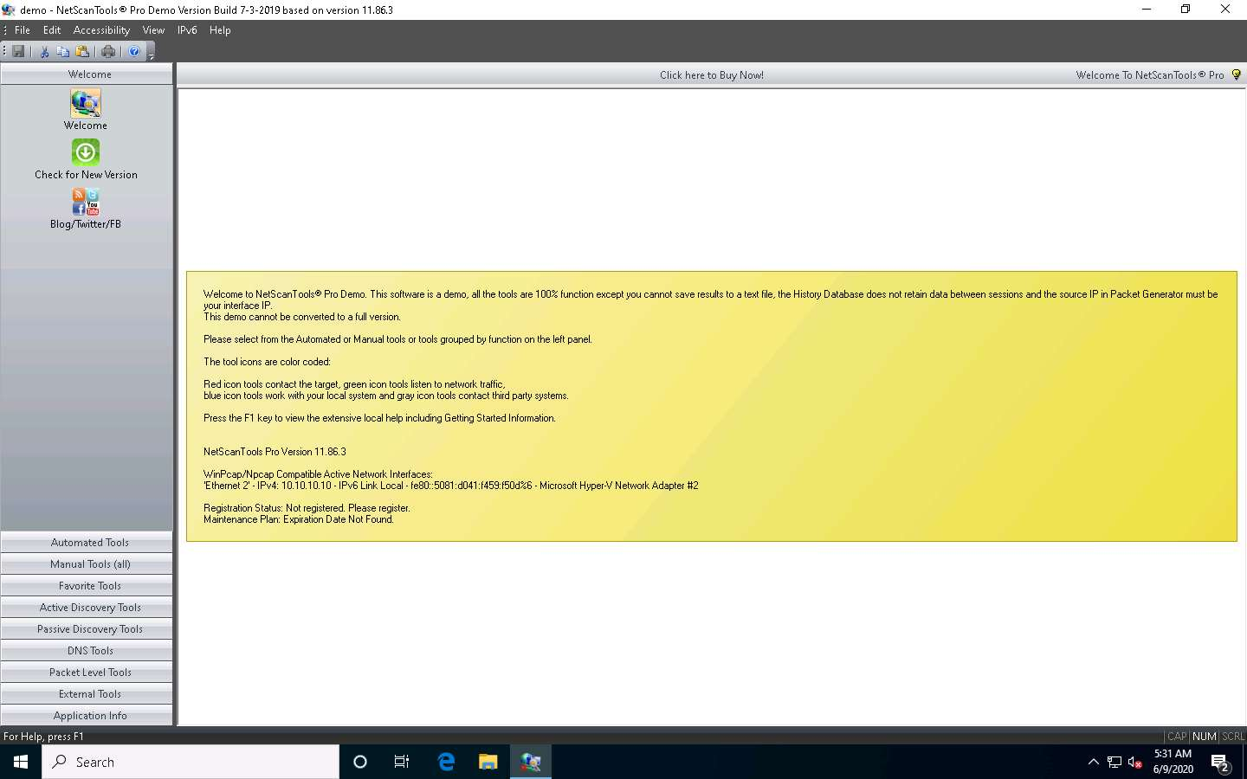

1. In the left pane, under the **Manual Tools (all)** section, scroll down and click the **SMB Scanner** option, as shown in the screenshot.

If a dialog box appears explaining the tool, click **OK**.

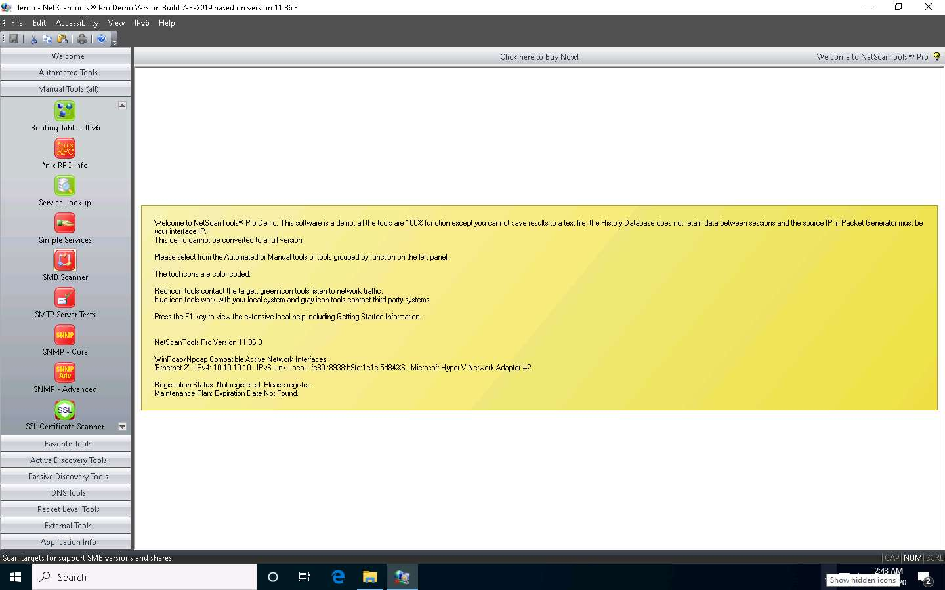

1. In the right pane, click the **Start SMB Scanner (external App)** button.

If the **Demo Version Message** pop-up appears, click **OK**. In the **Reminder** window, click **Start the DEMO**.

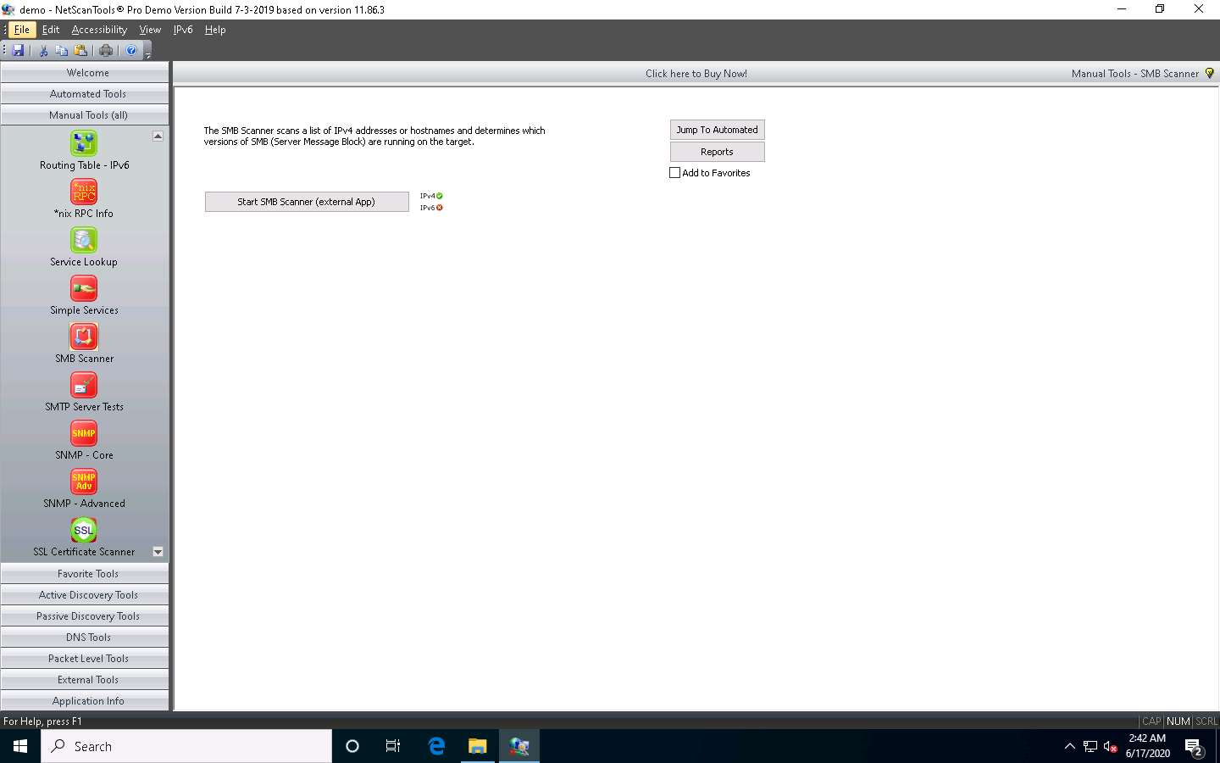

1. The **SMB Scanner** window appears; click the **Edit Target List** button.

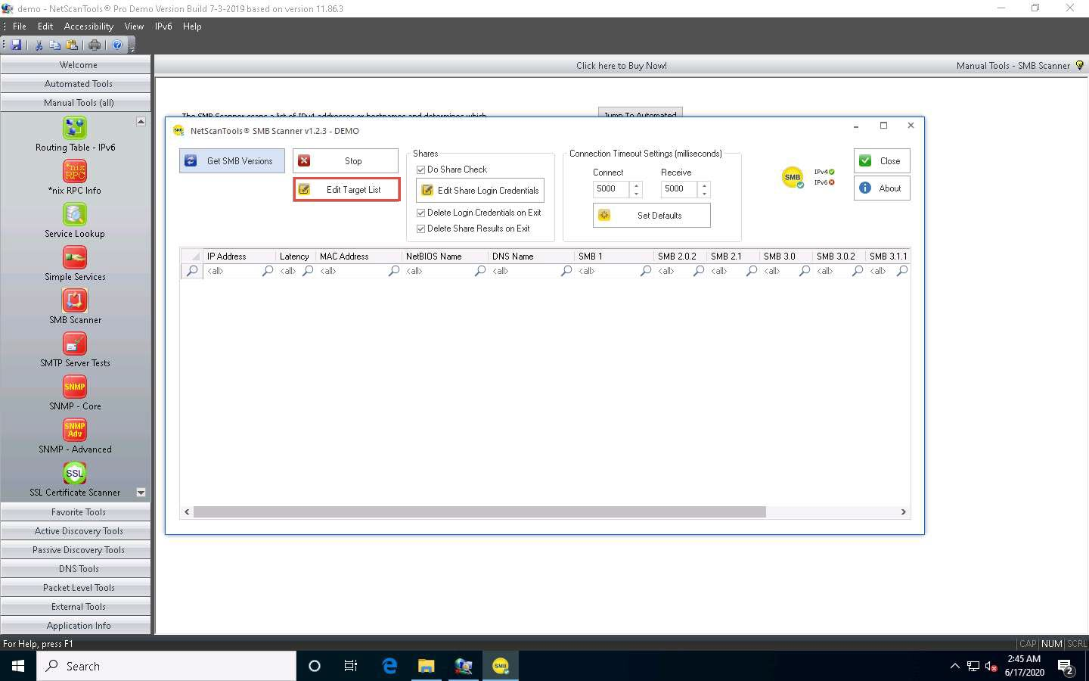

1. The **Edit Target List** window appears. In the **Hostname or IPv4 Address** field, enter the target IP address (**10.10.10.19**, in this example). Click the **Add to List** button to add the target IP address to **Target List**.
2. Similarly, add another target IP address (**10.10.10.16**, in this example) to **Target List** and click **OK**.

In this task, we are targeting the **Windows Server 2019** (10.10.10.19) and **Windows Server 2016** (10.10.10.16) machines.

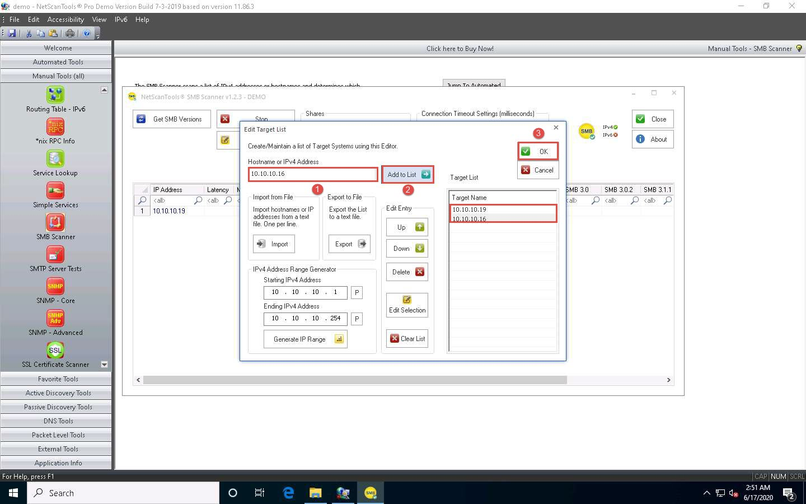

1. Now, click **Edit Share Login Credentials** to add credentials to access the target systems.

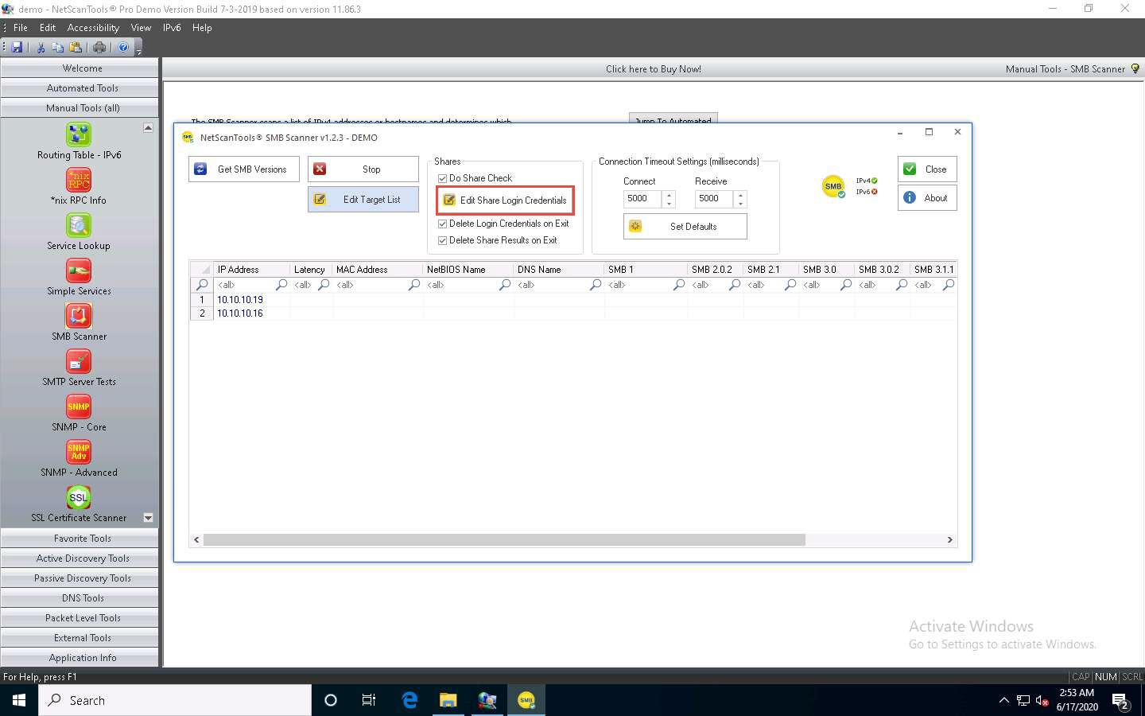

1. The **Login Credentials List for Share Checking** window appears. Enter **Administrator** and **Pa$$w0rd** in the **Username** and **Password** fields, respectively. Click **Add to List** to add the credentials to the list and click **OK**.

In this task, we are using the login credentials for the **Windows Server 2019** and **Windows Server 2016** machines to understand the tool. In reality, attackers may add a list of login credentials by which they can log in to the target machines and obtain the required SMB share information.

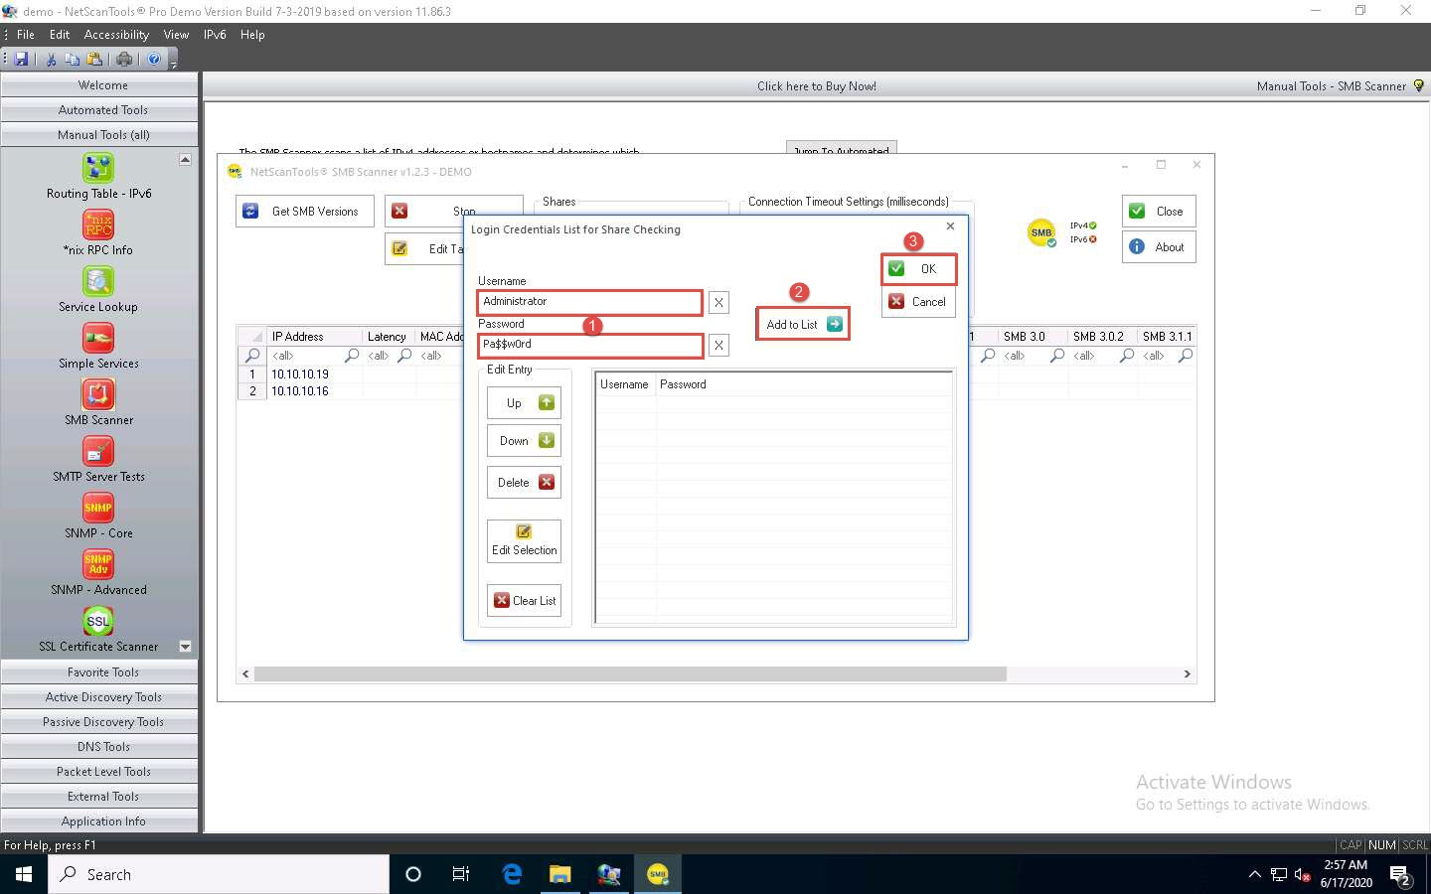

1. In the **SMB Scanner** window, click the **Get SMB Versions** button.
2. Once the scan is complete, the result appears, displaying information such as the NetBIOS Name, DNS Name, SMB versions, and Shares for each target IP address.

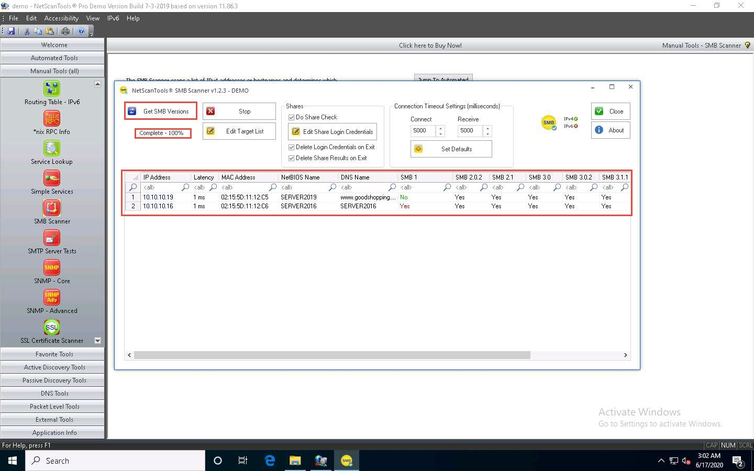

1. Right-click on any of the machines (in this example, we will use **10.10.10.19**) and click **View Shares** from the available options.

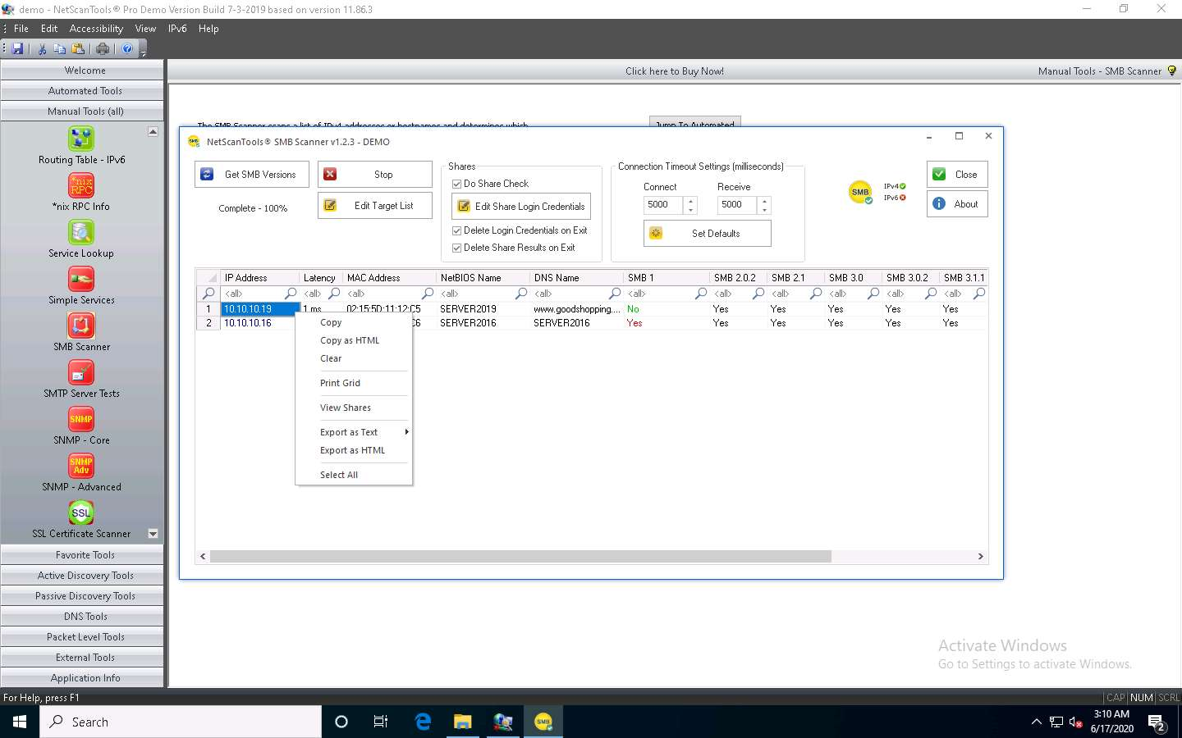

1. The **Shares for 10.10.10.19** window appears, displaying detailed information about shared files such as Share Name, Type, Remark, Path, Permissions, and Credentials Used.

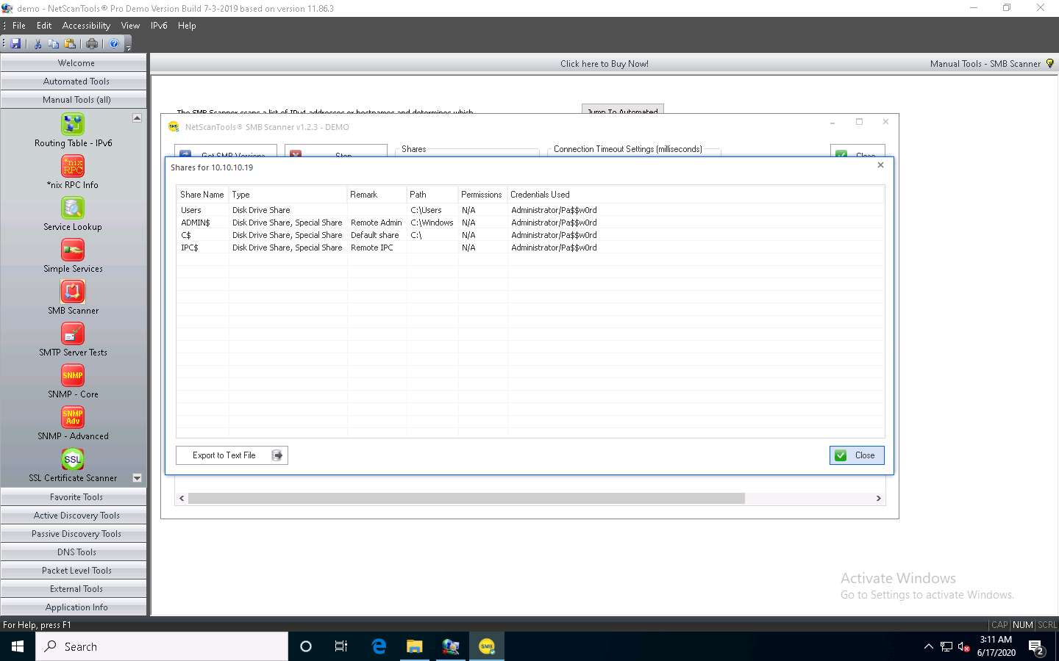

1. You can view the details of the shared files for the target IP address **10.10.10.16** in the same way.
2. This concludes the demonstration of performing SMB enumeration on the target systems using NetScanTools Pro.
3. Close all open windows and document all the acquired information.

Task 2: Perform RPC, SMB, and FTP Enumeration using Nmap

Nmap is a utility used for network discovery, network administration, and security auditing. It is also used to perform tasks such as network inventory, service upgrade schedule management, and host or service uptime monitoring.

Here, we will use Nmap to carry out RPC, SMB, and FTP enumeration.

Before starting this lab, we must configure the FTP service in the target machine (**Windows Server 2019**). To do so, follow **Steps 1-10**.

1. Click [Windows Server 2019](https://labclient.labondemand.com/Instructions/fbc14e54-d7e0-48c8-a161-917c8a669df5?rc=10) to switch to the **Windows Server 2019** machine.
2. Click on the **File Explorer** icon at the bottom of **Desktop**. In the **File Explorer** window, right-click on **Local Disk (C:)** and click **New** --> **Folder**.

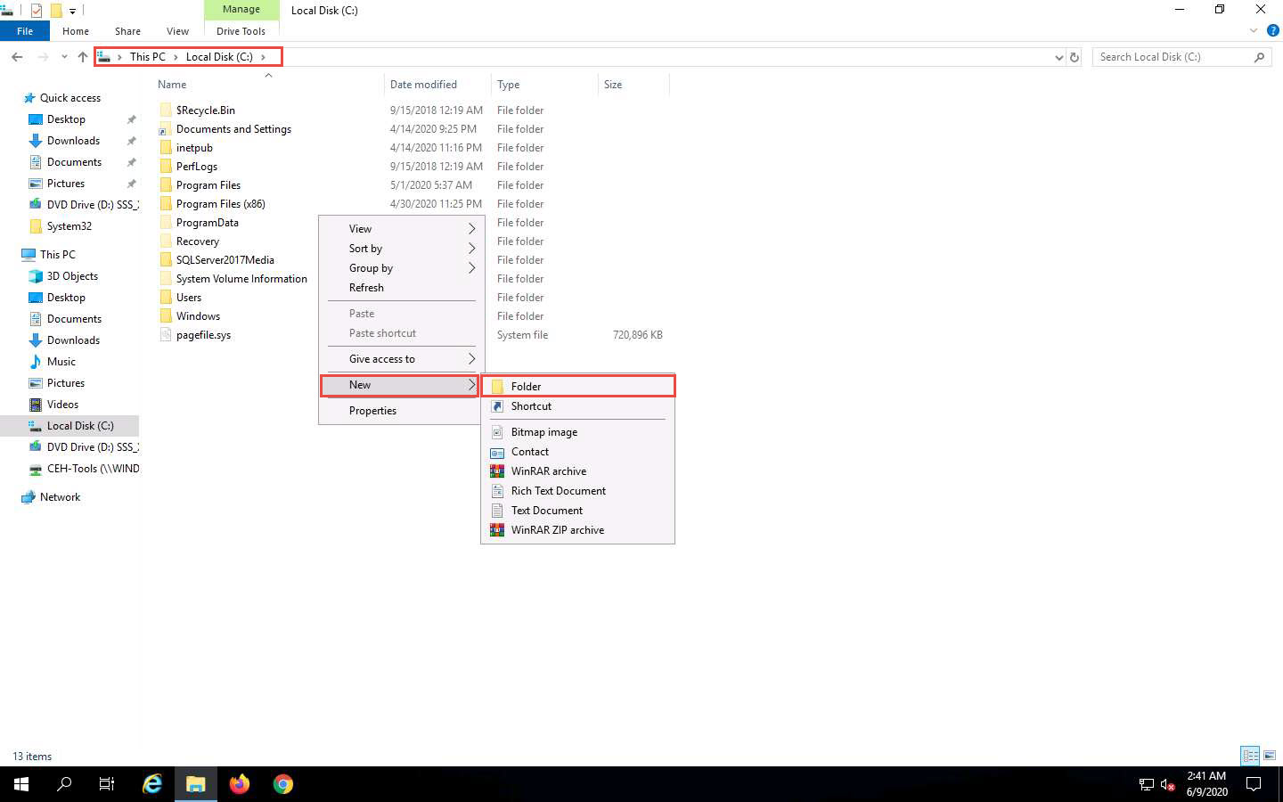

1. A **New Folder** appears. Rename it to **FTP-Site Data**, as shown in the screenshot.

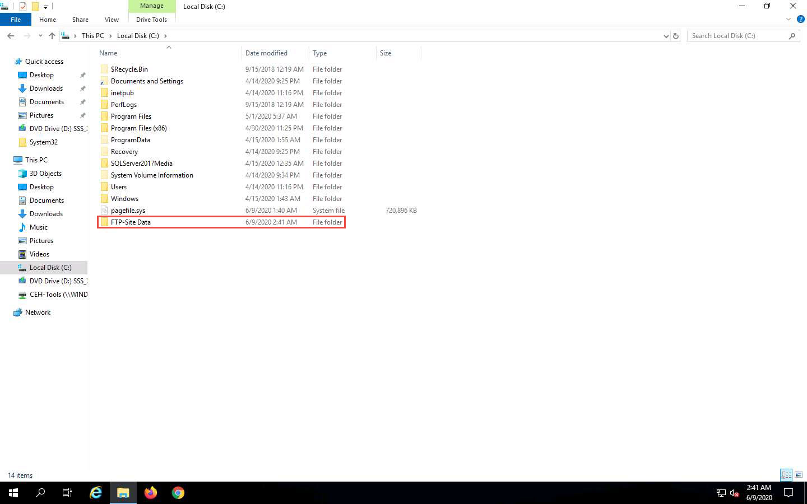

1. Close the window and click on the **Type here to search** icon at the bottom of the **Desktop**. Type **iis**. In the search results, click on **Internet Information Services Manager (IIS) Manager**, as shown in the screenshot.

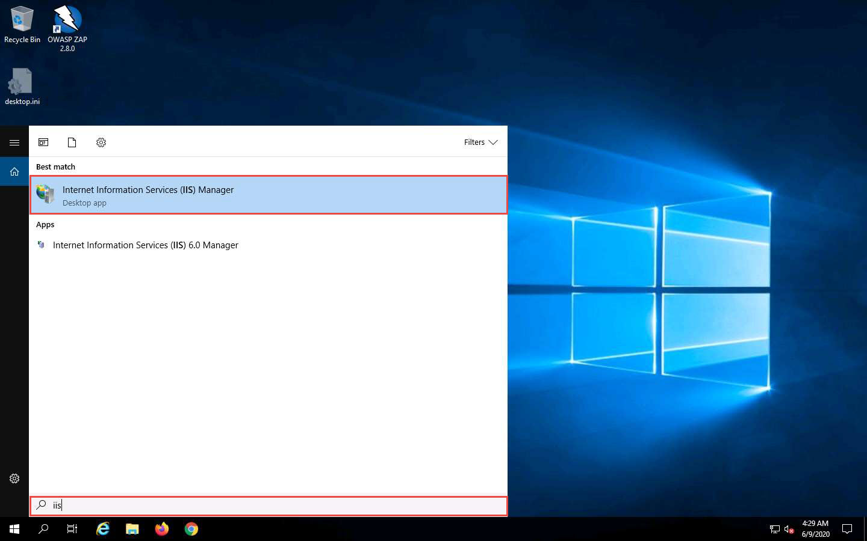

1. In the **Internet Information Services (IIS) Manager** window, click to expand **SERVER2019 (SERVER2019\Administrator)** in the left pane. Right-click **Sites**, and then click **Add FTP Site…**.

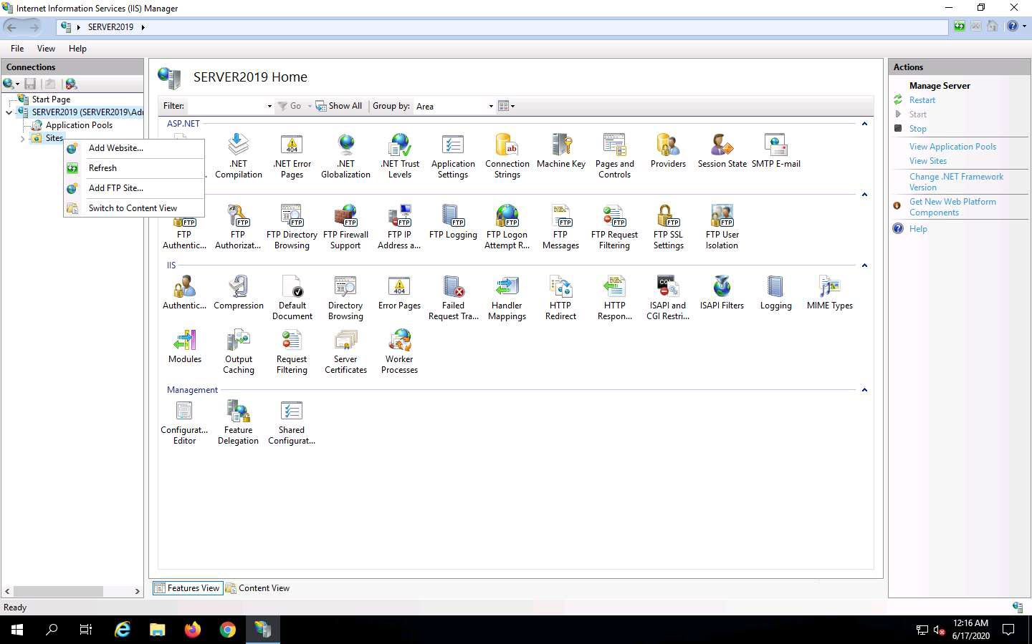

1. In the **Add FTP Site** window, type **CEH.com** in the **FTP site name** field. In the **Physical path** field, click on the icon. In the **Browse For Folder** window, click **Local Disk (C:)** and **FTP-Site Data**, and then click **OK**.

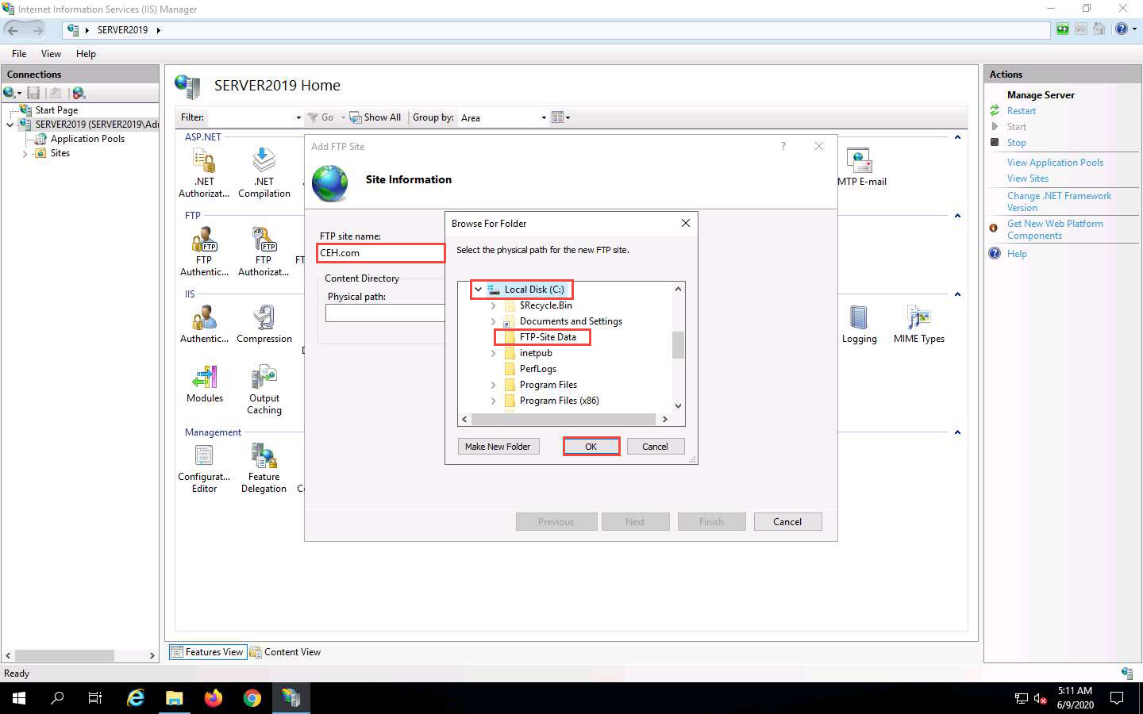

1. In the **Add FTP Site** window, check the entered details and click **Next**.

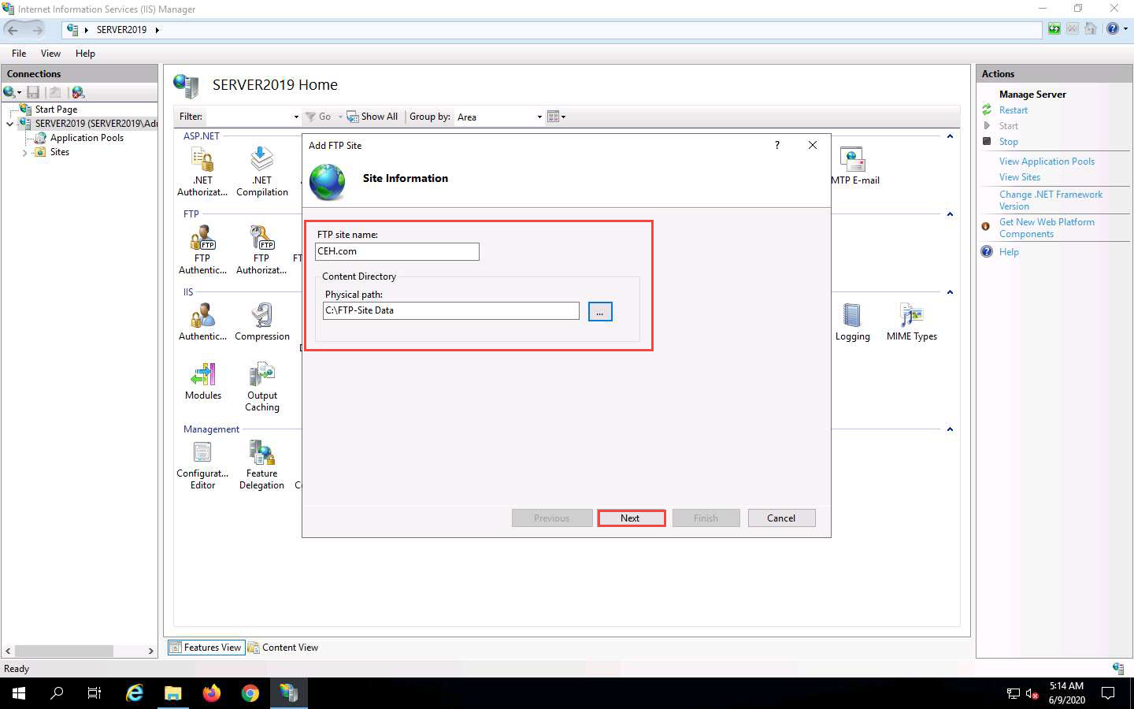

1. The **Binding and SSL Settings** wizard appears. Under the **Binding** section, in the **IP Address** field, click the drop-down icon and select **10.10.10.19**. Under the **SSL** section, select the **No SSL** radio button and click **Next**.

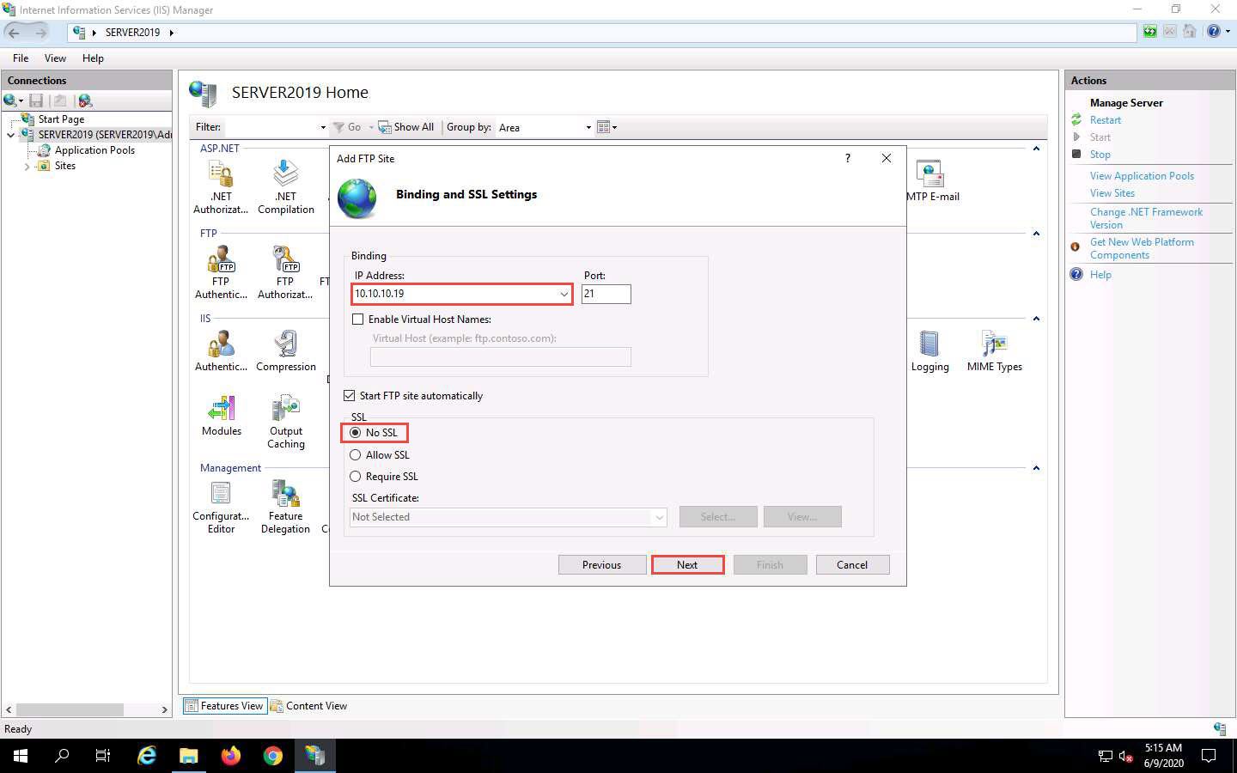

1. The **Authentication and Authorization Information** wizard appears. In the **Allow access to** section, select **All users** from the drop-down list. In the **Permissions** section, select both the **Read** and **Write** options and click **Finish**.

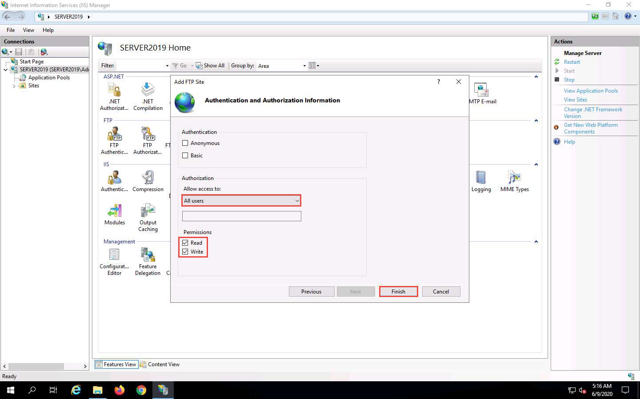

1. The **Internet Information Services (IIS) Manager** window appears with a newly added FTP site (**CEH.com**) in the left pane. Click the **Site** node in the left pane and note that the **Status** is **Started** (**ftp**), as shown in the screenshot.

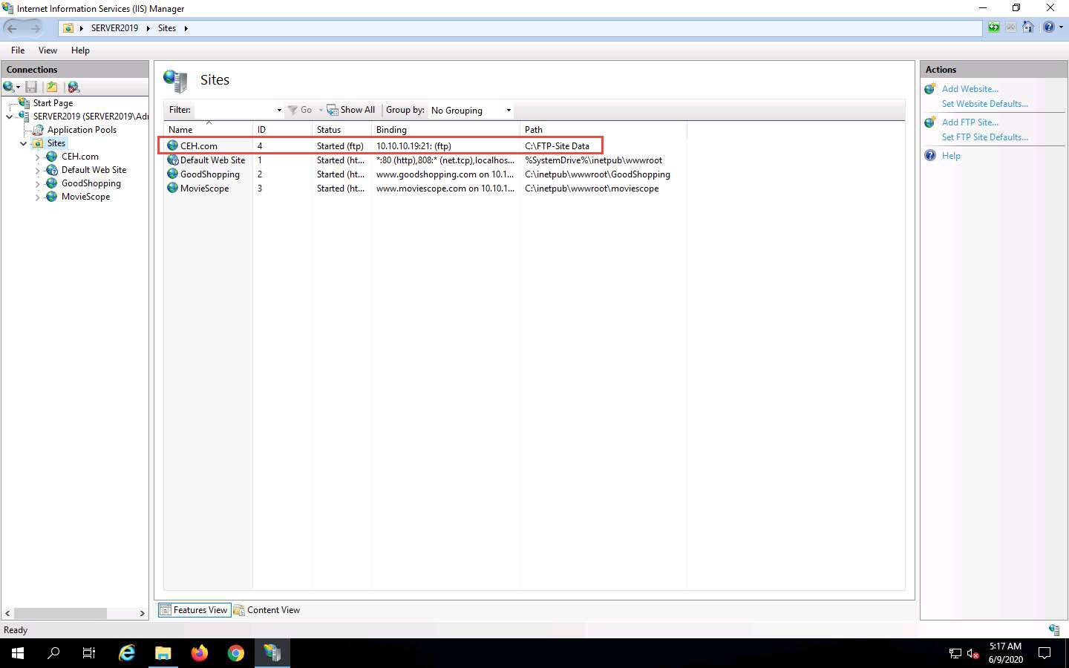

1. Close all windows.
2. Click [Parrot Security](https://labclient.labondemand.com/Instructions/fbc14e54-d7e0-48c8-a161-917c8a669df5?rc=10) to switch to the **Parrot Security** machine.
3. Click the **MATE Terminal** icon at the top of the **Desktop** window to open a **Terminal** window.

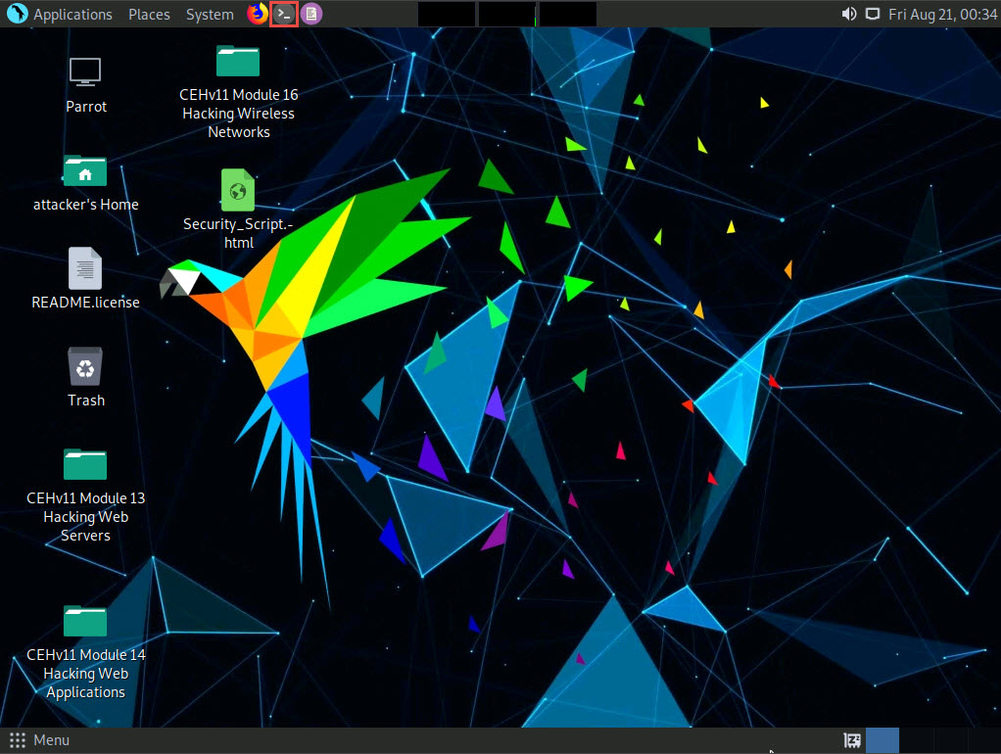

1. A **Parrot Terminal** window appears. In the terminal window, type **sudo su** and press **Enter** to run the programs as a root user.
2. In the **[sudo] password for attacker** field, type **toor** as a password and press **Enter**.

The password that you type will not be visible.

1. Now, type **cd** and press **Enter** to jump to the root directory.

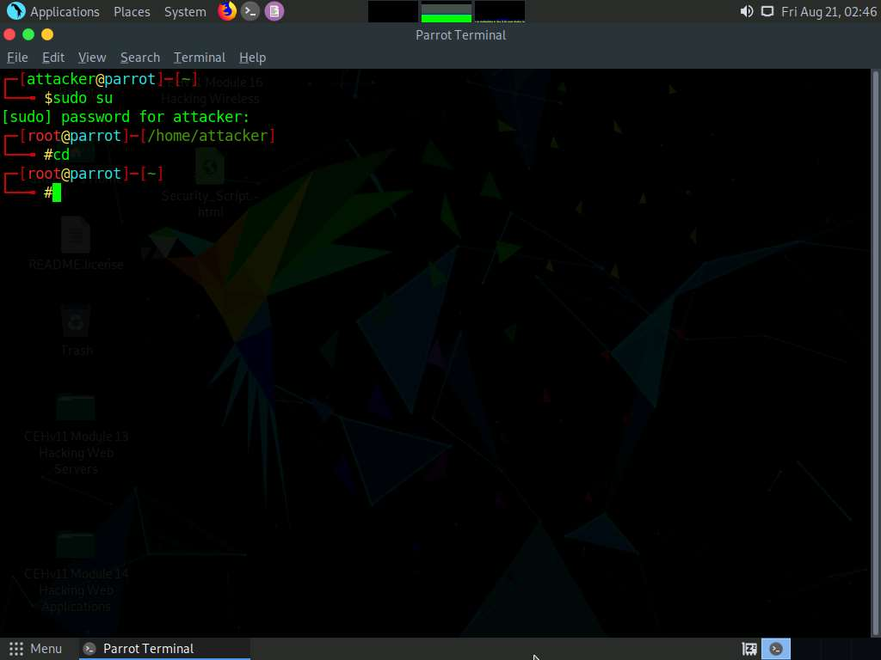

1. In the **Parrot Terminal** window, type **nmap -p 21 [Target IP Address]** (in this case, **10.10.10.19**) and press **Enter**.
2. The scan result appears, indicating that port 21 is open and the FTP service is running on it, as shown in the screenshot.

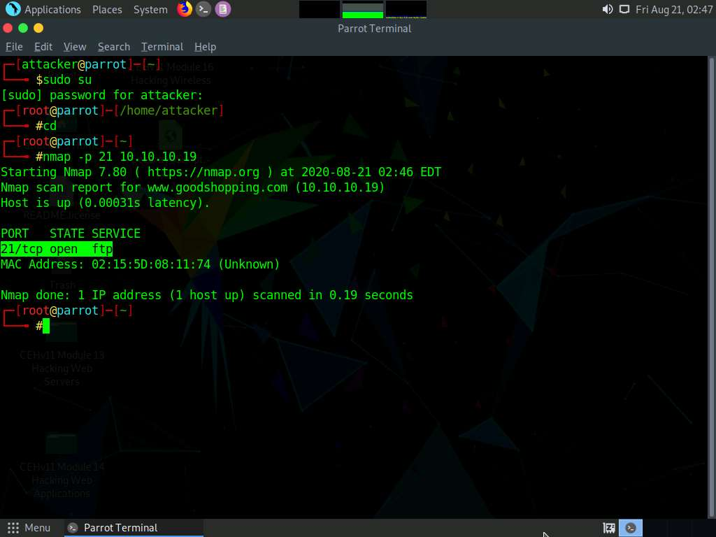

1. In the terminal window, type **nmap -T4 -A [Target IP Address]** (in this example, the target IP address is **10.10.10.19**) and press **Enter**.

In this command, **-T4** specifies the timing template (the number can be 0-5) and **-A** specifies aggressive scan. The aggressive scan option supports OS detection (-O), version scanning (-sV), script scanning (-sC), and traceroute (--traceroute).

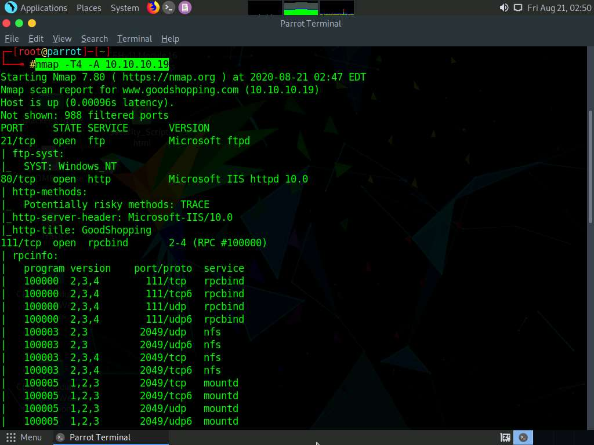

1. The scan result appears, displaying that port 80 is open, and giving detailed information about the services running on it, along with their versions.

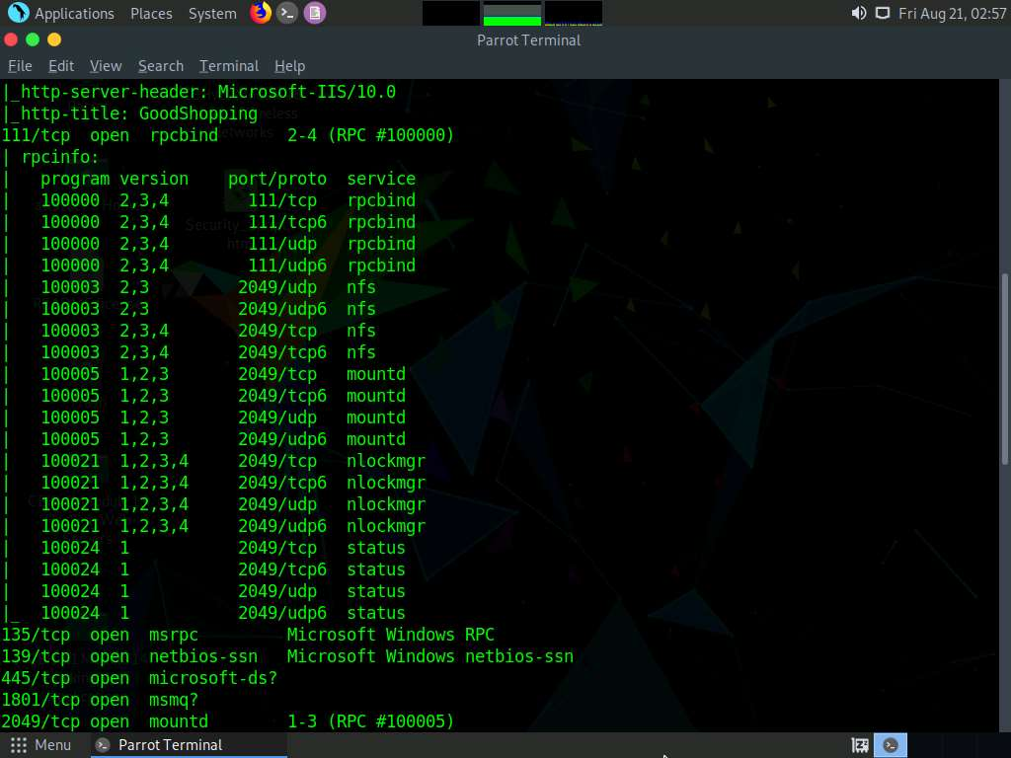

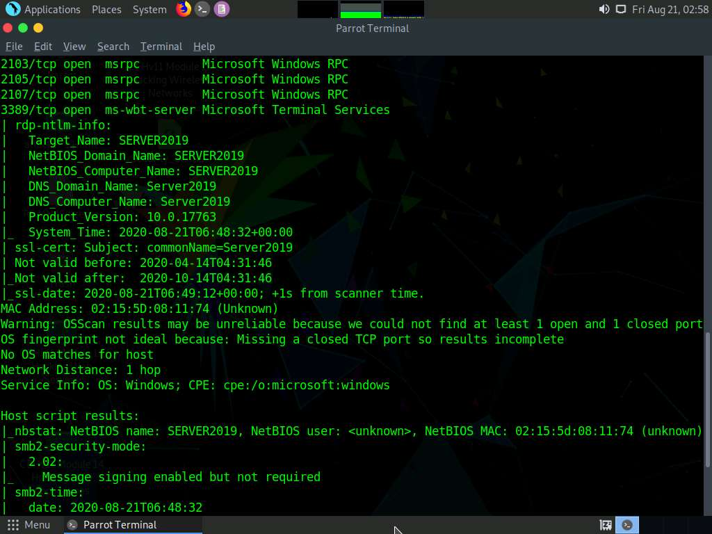

1. Click the **MATE Terminal** icon at the top of the **Desktop** window to open a new **Terminal** window.
2. A **Parrot Terminal** window appears. In the terminal window, type **sudo su** and press **Enter** to run the programs as a root user.
3. In the **[sudo] password for attacker** field, type **toor** as a password and press **Enter**.

The password that you type will not be visible.

1. Now, type **cd** and press **Enter** to jump to the root directory.

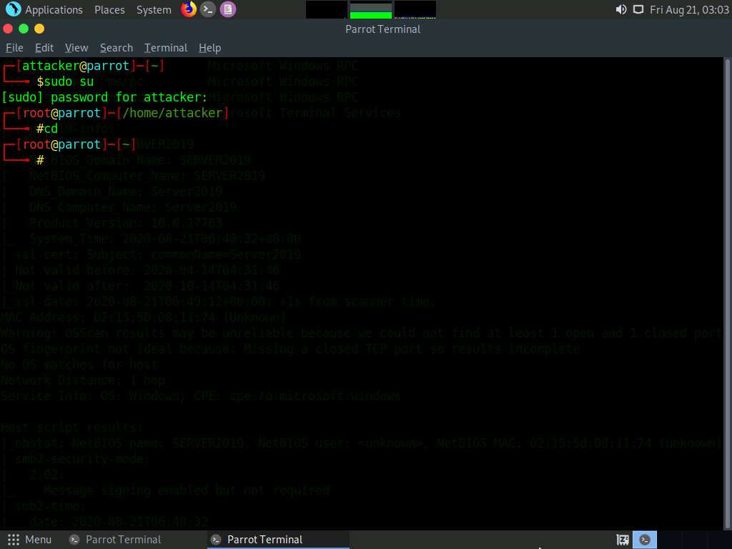

1. In the terminal window, type **nmap -p [Target Port] -A [Target IP Address]** (in this example, the target port is **445** and the target IP address is **10.10.10.19**) and press **Enter**.

In this command, **-p** specifies the port to be scanned, and **-A** specifies aggressive scan. The aggressive scan option supports OS detection (-O), version scanning (-sV), script scanning (-sC), and traceroute (--traceroute).

1. The scan result appears, displaying that port 445 is open, and giving detailed information under the **Host script results** section about the running SMB, as shown in the screenshot.

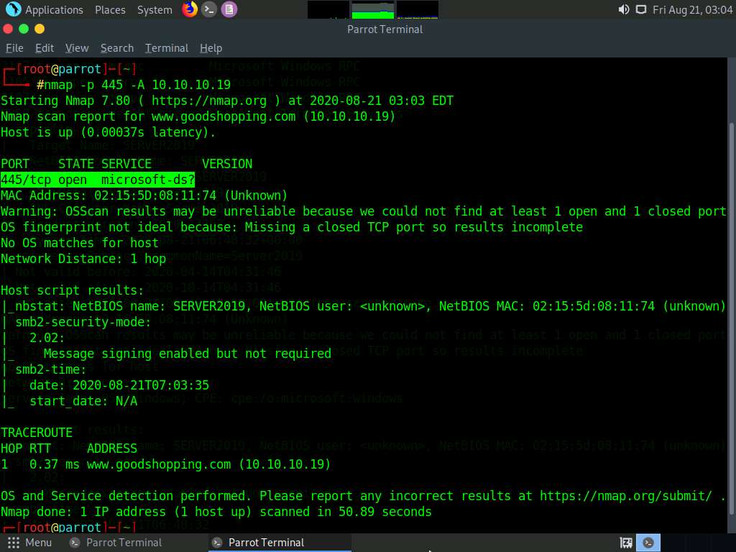

1. In the terminal window, type **nmap -p [Target Port] -A [Target IP Address]** (in this example, the target port is **21** and target IP address is **10.10.10.19**) and press **Enter**.

In this command, **-p** specifies the port to be scanned and **-A** specifies aggressive scan. The aggressive scan option supports OS detection (-O), version scanning (-sV), script scanning (-sC), and traceroute (--traceroute).

1. The scan result appears, displaying that port 21 is open, and giving traceroute information, as shown in the screenshot.

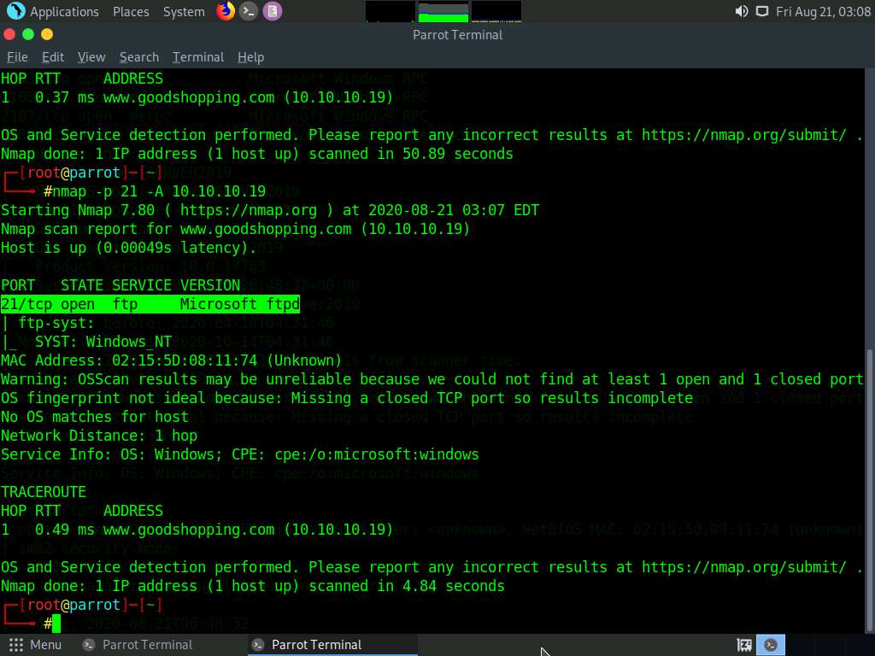

1. This concludes the demonstration of performing RPC, SMB, and FTP enumeration using Nmap.
2. Close all open windows and document all the acquired information.